**Data Science for Engineers**

**Lab Report 2**

**Rebal Ahmad**

**19l-1404**

**Section-8A**

Loops, functions and arrays in python

**INTRODUCTION:**

Python is a free open-source programming language that is utilized in numerous scientific applications, data science, artificial intelligence, and web programming.Programmers who learn Python are able to concentrate on problem-solving rather than syntax.It has an advantage over languages like Java and C++ due to its relative size and simplified syntax, but the abundance of libraries gives it the power to do great things.Colaboratory, or simply "Colab," is a Google Research product.Colab is ideal for machine learning, data analysis, and education because it lets anyone write and run any Python code through a browser.Colab resources are not guaranteed or unlimited, and their limits for use can change from time to time.Colab can't offer its resources for free unless this is done.See Resource Limits for more information. Colab Pro may be of interest to users seeking more dependable access to superior resources.

**OBJECTIVES:**

● To be able to use Google Colab for compiling simple python Programs.

● To get familiar with loops, functions and arrays in python

● To be able to understand and solve programming problems using python

**Remaining inlabs:**

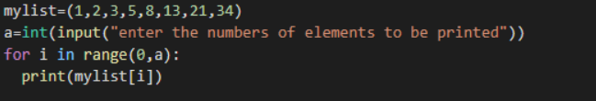

**Application:**

Applications for Python include:

Machine learning and artificial intelligence, game development, data science and data visualization, desktop graphical user interfaces, web scraping applications, business applications, audio and video applications, CAD applications, and embedded applications are all examples of these areas.

**Issues:**

we never find any issue regarding this lab.

**Conclusion:**

This experiment has taught us the fundamentals of Python and google colab.

**Post lab:**



